Online Exam Management System
A Project Report
Submitted to the Faculty of Engineering of
JAWAHARLAL NEHRU TECHNOLOGICAL UNIVERSITY KAKINADA,
KAKINADA
In partial fulfillment of the requirements for the award of the Degree of
BACHELOR OF TECHNOLOGY
In
COMPUTER SCIENCE AND ENGINEERING
By
M.Divya Sree K.Anusha
(24481A05O0) (24481A05K2)
N.Sumathi M.Lalith Vardhan
(24481A05Q1) (24481A05M1)
Under the guidance of
Mrs.P.Reshma , M.Tech(ph.D.)
Assistant Professor of CSE Department

DEPARTMENT OF COMPUTER SCIENCE AND ENGINEERING
SESHADRI RAO GUDLAVALLERU ENGINEERING COLLEGE

(An Autonomous Institute with Permanent Affiliation to JNTUK,Kakinada)
SESHADRI RAO KNOWLEDGE VILLAGE
GUDLAVALLERU – 521356
ANDHRA PRADESH
2025-2026

SESHADRI RAO GUDLAVALLERU ENGINEERING COLLEGE
(An Autonomous Institute with Permanent Affiliation to JNTUK, Kakinada)
SESHADRI RAO KNOWLEDGE VILLAGE, GUDLAVALLERU

DEPARTMENT OF COMPUTER SCIENCE AND ENGINEERING


CERTIFICATE
This is to certify that the project report entitled “PROJECT TITLE” is a bonafide record of work carried out by M.Divya Sree (24481A05O0), K.Anusha (24481A05K2), M.Lalith Vardhan(24481A05M1) ,N,Sumathi(24481A05Q1) under the guidance and super vision in the partial fulfillment of the requirements for the award of the degree of Bachelor of Technology in Computer Science and Engineering of Jawaharlal Nehru Technological University Kakinada, Kakinada during the academic year 2025-26.
Project Guide Head of Department
Mrs.P.Reshma Dr.M.Babu Rao

ACKNOWLEDGEMENT
The satisfaction that accompanies the successful completion of any task would be incomplete without the mention of people who made it possible and whose constant guidance and encouragements crown all the efforts with success.
We would like to express our deep sense of gratitude and sincere thanks to Mrs. P.Reshma, Department of Computer Science and Engineering for her constant guidance, supervision and motivation in completing the project work.
We feel elated to express our floral gratitude and sincere thanks to Dr. M.Babu Rao, Head of the Department, Computer Science and Engineering for their encouragements all the way during analysis of the project. Their annotations, insinuations and criticisms are the key behind the successful completion of the project work.
We would like to take this opportunity to thank our beloved principal Dr. B.Karuna Kumar for providing great support for us in completing our project and giving us the opportunity for doing project.
Our Special thanks to the faculty of our department and programmers of our computer lab. Finally, we thank our family members, non-teaching staff and our friends, who had directly or indirectly helped and supported us in completing our project in time.
Team members
M.Divya sree (24481A05O0)
M.Anusha (24481A05K2)
M.Sumati (24481A05Q1)
M.Lalith Vardhan (24481A05M1)

S. No | Title | Page No
1 | List of Abbreviations | i
2 | List of Figures | ii
3 | List of Tables | iii
4 | Abstract | iv
5 | Chapter 1: Introduction | 1
 | 1.1 Introduction
 | 1.2 Objectives of the Project
 | 1.3 Problem Statement
6 | Chapter 2: Project Overview | 2-10
 | 2.1 Development & Client Details
 | 2.2 Requirement Analysis
 | 2.2.1 Functional Requirements
 | 2.2.2 Non-Functional Requirements
 | 2.3 Security & RBAC
 | 2.4 Physical Design (Tables & Constraints)
 | 2.5 ER Diagram & Structural Design
 | 2.6 Normalization
 | 2.6.1 Before Normalization
 | 2.6.2 After Normalization
7 | Chapter 3: Proposed Method | 11-14
 | 3.1 Methodology
 | 3.2 Recommendation Algorithm
 | 3.3 Implementation
 | 3.4 Transactions & ACID Properties
8 | Chapter 4: Testing & Test Cases | 15-19
9 | Chapter 5: Results and Discussion | 20-23
10 | Chapter 6: Conclusion & Future Scope | 24-25
 | 6.1 Conclusion
 | 6.2 Future Scope
11 | Bibliography | 26
12 | Program Outcomes & Program Specific Outcomes | 27
CONTENTS

LIST OF ABBREVIATIONS
Abbreviation | Full Form
 | Software Requirements Specification
DBMS | Database Management System
RDBMS | Relational Database Management System
SQL | Structured Query Language
UI SRS | User Interface
NLP | Natural Language Processing
RBAC | Role-Based Access Control
ER | Entity Relationship
ERD | Entity Relationship Diagram
PK | Primary Key
FK | Foreign Key
ACID | Atomicity, Consistency, Isolation, Durability
API | Application Programming Interface
CRUD | Create, Read, Update, Delete

LIST OF FIGURES
Figure No | Title | Page No
Fig 2.1 | System Architecture Diagram | 7
Fig 2.2 | ER Diagram of Movie Recommendation System | 8
Fig 3.1 | Login/register page | 12
Fig 5.1 | Admin dashboard | 21
Fig 5.2 | Question Management Interface | 21
Fig 5.3 | Timer-Based Exam Screen | 22
Fig 5.4 | Result Display Page | 22
Fig 5.5 | Database Tables Structure | 23
Fig 5.6 | User Role-Based Access Interface (Admin/Faculty/Student) | 23

Table No | Table Name | Page No
Table 2.1 | Development Table | 3
Table 2.2 | Client Table | 3
Table 2.3 | Functional Requirements | 10
Table 2.4 | Non-Functional Requirements | 11
Table 2.6 | Users Table Schema | 14
Table 2.7 | Cast Table Schema | 15
Table 2.9 | Before Normalization (Sample) | 18
Table 2.10 | After Normalization (Sample) | 18
Table 4.1 | Functional Test Cases | 24
Table 4.2 | Insert Test Cases | 25
Table 4.3 | Update Test Cases | 26
Table 4.4 | Delete Test Cases | 27
LIST OF TABLES

ABSTRACT
The Online Exam Management System is a web-based application designed to streamline and automate the process of conducting examinations, managing student data, and generating results efficiently. Traditional examination systems often involve manual processes that are time-consuming, error-prone, and difficult to manage, especially with large numbers of students. This project aims to provide a digital solution that simplifies these tasks through an interactive and user-friendly platform.
The system allows administrators, instructors, and students to interact within a centralized environment. Administrators can create and manage exams, upload questions, set time limits, and monitor ongoing examinations. Instructors can evaluate performance and maintain academic records, while students can register, log in securely, take exams online, and instantly view their results. The system supports multiple types of questions, including multiple-choice questions (MCQs), and ensures fairness by randomizing questions and options.
The backend of the system is powered by a structured database management system (DBMS), which efficiently stores user information, exam details, and results. SQL queries are used to perform operations such as data insertion, retrieval, updating, and deletion. The frontend is developed using HTML, CSS, and JavaScript to provide an intuitive and responsive user interface, ensuring accessibility across different devices.
Security is a key aspect of this system. Authentication mechanisms such as login credentials and session management are implemented to protect user data and prevent unauthorized access. Additionally, the system can include features like timer-based exams, automatic submission, and result calculation, reducing human intervention and minimizing errors.
The Online Exam Management System improves efficiency, reduces administrative workload, and enhances the overall examination experience. It provides scalability for institutions to handle a large number of users simultaneously and ensures accuracy in result processing. This project demonstrates the practical application of web technologies and database management in solving real-world problems in the education sector.
CHAPTER 1: INTRODUCTION
1.1 Introduction
The rapid growth of information technology has significantly influenced various sectors, especially education. With the increasing demand for digital solutions, educational institutions are moving from traditional methods to automated systems. One such advancement is the Online Exam Management System, which provides a modern approach to conducting examinations efficiently and securely. Traditional examination systems rely heavily on manual processes such as preparing question papers, conducting exams in physical classrooms, and evaluating answer sheets, which can be time-consuming, costly, and prone to errors.
The Online Exam Management System is designed to overcome these limitations by providing a web-based platform where exams can be conducted online. This system allows students to appear for exams from any location, while administrators can manage exams, questions, and results through a centralized interface. The use of technologies like HTML, CSS, and JavaScript ensures an interactive and user-friendly experience, while a database management system (DBMS) helps in storing and managing large volumes of data efficiently.
This system not only improves the speed and accuracy of the examination process but also enhances transparency and accessibility. It reduces the dependency on paper-based exams and enables institutions to conduct exams in a more flexible and scalable manner.

1.2 Objectives of the Project
The main objective of developing the Online Exam Management System is to create an efficient, reliable, and secure platform for conducting online examinations. The system aims to simplify the entire examination process, from exam creation to result generation, while minimizing human intervention and errors. It focuses on providing convenience to both administrators and students by offering an easy-to-use interface and automated functionalities.
The project also aims to ensure that exams can be conducted in a fair and secure environment. Features such as authentication, time limits, and automated evaluation help maintain the integrity of the examination process. Additionally, the system is designed to be scalable and adaptable, making it suitable for various educational institutions.
Key Points:
- To develop a web-based online examination platform
- To automate the exam conduction and evaluation process
- To provide secure login and authentication
- To enable easy creation and management of exams
1.3 Problem Statement
Traditional examination systems face several challenges that affect their efficiency and reliability. The manual preparation and evaluation of exams require significant time and effort from educators, leading to delays in result processing. Human errors in checking answer sheets and calculating marks can also impact the accuracy of results. Moreover, managing large amounts of student data and exam records becomes difficult without a proper digital system.
Another major issue is the lack of flexibility in traditional exams. Students are required to be physically present at a specific location and time, which may not always be convenient. Situations such as pandemics or remote learning environments further highlight the need for an online solution. Additionally, traditional systems involve high costs for printing question papers and maintaining infrastructure.
Therefore, there is a strong need for a system that can address these limitations by providing a secure, efficient, and automated solution. The Online Exam Management System is proposed to eliminate these issues by offering a digital platform that improves accessibility, reduces errors, and enhances overall efficiency.
CHAPTER 2:Project Overview
2.1 Development & Client Details
The Online Exam Management System is developed as a database-driven web application to provide a secure and efficient platform for conducting online examinations. The system is designed to help educational institutions manage exams, evaluate student performance, and maintain records digitally. It is useful for students, faculty members, and administrators by simplifying the entire examination process.

DEVELOPMENT
Name of the development organization: [Your College Name]
Table 2.1: Development Table
Sl. No | Role | Responsibility
1 | Database Administrator (DBA) | Manages database, security, backup, indexing, and performance optimization
2 | System Analyst (SA) | Analyzes system requirements, defines exam workflow, and prepares system specifications
3 | Database Designer (DD) | Designs ER diagram, performs normalization (1NF, 2NF, 3NF), and creates table schemas
4 | Application Programmer (AP) | Develops frontend (HTML, CSS, JS), implements exam logic, integrates database, and handles validation

CLIENT
Nature of the organization: Education / Service-Based
Name of the module to develop: Online Exam Management System
Table 2.2: Client Table
Sl. No | Role | Responsibility
1 | Student (Naive User) | Registers, logs in, takes exams, and views results
2 | Faculty (Sophisticated User) | Creates questions, manages exams, and monitors student performance
3 | Guest/Casual User | Views basic information or demo (if applicable)
4 | Administrator (Specialized User) | Manages users, exams, results, and system configuration

2.2 Requirement Analysis
Requirement analysis is the process of identifying and analyzing the needs and expectations of users. It defines what the system should do (functional requirements) and how the system should perform (non-functional requirements). Proper requirement analysis ensures that the system is efficient, reliable, and meets user expectations.
2.2.1 Functional Requirements
Functional requirements describe the operations and functionalities that the system should perform.
Table 2.3: Functional Requirements
Test Case ID | Description | Action | Expected Result | Result
-------------- | ------------ | -------- | ----------------- | --------
FR_TC01 | User registration | Enter details & submit | Account created | Pass
FR_TC02 | User login | Enter username & password | Login successful | Pass
FR_TC03 | Create exam | Admin creates exam | Exam stored in DB | Pass
FR_TC04 | Add questions | Faculty adds MCQs | Questions saved | Pass
2.2.2 Non-Functional Requirements
Non-functional requirements describe how the system performs its operations. The non-functional requirements of the system are:
- Usability – The system shall have an intuitive glass-morphism user interface with clear labels, buttons, and feedback messages.
- Performance – The system shall generate recommendations within 3 seconds for a database of up to 1000 movies.
- Response Time – The system shall display mood tags in real-time (under 100ms after user stops typing).
- Data Integrity – The system shall maintain referential integrity through foreign key constraints between Movies, Cast, and Movie_Images tables.

Table 2.4: Non-Functional Requirements
Test Case ID | Description | Action | Expected Result | Result
NFR_TC01 | System performance | Multiple users access system | Fast response time | Pass
NFR_TC02 | Security | User login with credentials | Secure authentication | Pass
NFR_TC03 | Usability | User navigates system | Easy to use interface | Pass
NFR_TC04 | Reliability | System runs continuously | No crashes or failures | Pass
NFR_TC05 | Scalability | Increase number of users | System handles load | Pass
NFR_TC06 | Compatibility | Open in different browsers | Works on all browsers | Pass
NFR_TC07 | Maintainability | Update system features | Easy to modify | Pass
NFR_TC08 | Data Integrity | Store and retrieve data | Accurate data maintained | Pass

2.3 Security & RBAC
Security is a critical component of the Online Exam Management System. The system follows Role-Based Access Control (RBAC) principles to ensure that users can access only the functionalities permitted to their roles, thereby protecting sensitive data and maintaining system integrity.

Role | Permissions
Administrator | Add/update/delete users, create/manage exams, manage questions, view all results, maintain system settings
Faculty/Instructor | Create exams, add/update/delete questions, monitor student performance, view results
Student | Register/login, take exams, submit answers, view results and performance
Security Features Implemented
- Authentication – Secure login system using username and password to verify user identity.
- Authorization (RBAC) – Access to system features is restricted based on user roles (Admin, Faculty, Student).
- Input Validation – User inputs (such as login details and exam answers) are validated to prevent invalid or empty data.
- Session Management – User sessions are maintained securely and automatically expired after logout or inactivity.
- Database Security – Use of constraints (Primary Key, Foreign Key) ensures data consistency and prevents unauthorized modifications.
- Error Handling – System handles errors gracefully and displays appropriate messages without exposing sensitive information.
- Data Protection – Sensitive data is stored securely and access is restricted to authorized users only.
Future Security Enhancements
- Password hashing and encryption for secure storage of credentials
- Implementation of HTTPS for secure data transmission
2.4 Physical Design (Tables & Constraints)
Physical design describes the database tables and constraints used in the system. The main tables used in the Online Exam Management System are:
- Users Table – Stores all user-related information such as UserID, Name, Email, Password, and Role (Admin/Faculty/Student).
- Exams Table – Stores exam details including ExamID, Title, Description, Date, and Duration.
- Questions Table – Stores questions related to each exam, including QuestionID, ExamID, QuestionText, Options, and CorrectAnswer.
- Results Table – Stores student exam results such as ResultID, UserID, ExamID, Score, and Submission Time.
Constraints Used
- Primary Key (PK): Ensures each record is uniquely identified (e.g., UserID, ExamID).
- Foreign Key (FK): Maintains relationships between tables (e.g., ExamID in Questions table).
- NOT NULL: Ensures mandatory fields are not left empty.
- UNIQUE: Prevents duplicate values (e.g., Email in Users table).
- CHECK: Ensures valid data ranges (e.g., score ≥ 0).

Table 2.5:
Users Table:
Field Name | Data Type | Constraints | Description
UserID | INT | Primary Key, Auto Increment | Unique user identifier
Name | VARCHAR(100) | NOT NULL | User full name
Email | VARCHAR(100) | UNIQUE, NOT NULL | User email address
Password | VARCHAR(100) | NOT NULL | User password
Role | VARCHAR(20) | NOT NULL | User role (Admin/Faculty/Student)
Exams Table:
Field Name | Data Type | Constraints | Description
ExamID | INT | Primary Key, Auto Increment | Unique exam identifier
Title | VARCHAR(100) | NOT NULL | Exam title
Description | TEXT | NULL | Exam description
Date | DATE | NOT NULL | Exam date
Duration | INT | NOT NULL | Exam duration (minutes)
Questions Table
Field Name | Data Type | Constraints | Description
QuestionID | INT | Primary Key, Auto Increment | Unique question identifier
ExamID | INT | Foreign Key (References Exams(ExamID)) | Linked exam
QuestionText | TEXT | NOT NULL | Question content
OptionA | VARCHAR(255) | NOT NULL | Option A
OptionB | VARCHAR(255) | NOT NULL | Option B
OptionC | VARCHAR(255) | NOT NULL | Option C
OptionD | VARCHAR(255) | NOT NULL | Option D
CorrectAnswer | CHAR(1) | NOT NULL | Correct option (A/B/C/D)
Results Table
Field Name | Data Type | Constraints | Description
ResultID | INT | Primary Key, Auto Increment | Unique result identifier
UserID | INT | Foreign Key (References Users(UserID)) | Linked user
ExamID | INT | Foreign Key (References Exams(ExamID)) | Linked exam
Score | INT | CHECK (Score >= 0) | Marks obtained
SubmissionTime | DATETIME | NOT NULL | Exam submission time

SQL Creation Statements:
1. Users Table
CREATE TABLE Users (
UserID INT PRIMARY KEY AUTO_INCREMENT,
Name VARCHAR(100) NOT NULL,
Email VARCHAR(100) UNIQUE NOT NULL,
Password VARCHAR(100) NOT NULL,
Role VARCHAR(20) NOT NULL,
CreatedDate DATE DEFAULT CURRENT_DATE
);
2. Exams Table
CREATE TABLE Exams (
ExamID INT PRIMARY KEY AUTO_INCREMENT,
Title VARCHAR(100) NOT NULL,
Description TEXT,
ExamDate DATE NOT NULL,
Duration INT NOT NULL
);
3. Questions Table
CREATE TABLE Questions (
QuestionID INT PRIMARY KEY AUTO_INCREMENT,
ExamID INT,
QuestionText TEXT NOT NULL,
OptionA VARCHAR(255) NOT NULL,
OptionB VARCHAR(255) NOT NULL,
OptionC VARCHAR(255) NOT NULL,
OptionD VARCHAR(255) NOT NULL,
CorrectAnswer CHAR(1) NOT NULL,
FOREIGN KEY (ExamID) REFERENCES Exams(ExamID)
);
4. Results Table
CREATE TABLE Results (
ResultID INT PRIMARY KEY AUTO_INCREMENT,
UserID INT,
ExamID INT,
Score INT CHECK (Score >= 0),
SubmissionTime DATETIME NOT NULL,
FOREIGN KEY (UserID) REFERENCES Users(UserID),
FOREIGN KEY (ExamID) REFERENCES Exams(ExamID)
);
2.5 ER Diagram & Structural Design
The Entity Relationship Diagram (ER Diagram) is used to represent the structure of the database system. It shows the entities, their attributes, and the relationships between them in the Online Exam Management System.
Main Entities in the System
- USERS – Stores user account details
(UserID, Name, Email, Password, Role, CreatedDate)
- EXAMS – Stores exam details
(ExamID, Title, Description, ExamDate, Duration)
- QUESTIONS – Stores questions for each exam
(QuestionID, ExamID, QuestionText, OptionA, OptionB, OptionC, OptionD, CorrectAnswer)
- RESULTS – Stores exam results of students
(ResultID, UserID, ExamID, Score, SubmissionTime)
Relationships
- EXAMS has QUESTIONS
→ One-to-Many relationship
(One exam can have multiple questions)
- USERS attempts EXAMS
→ Many-to-Many relationship (implemented via RESULTS table)
(One user can take multiple exams, and one exam can be taken by multiple users)
- USERS has RESULTS
→ One-to-Many relationship
(One user can have multiple results)
- EXAMS has RESULTS
→ One-to-Many relationship
(One exam can generate multiple results)
Structural Design Summary
- Each entity is represented as a table in the database
- Primary keys uniquely identify records in each table
- Foreign keys establish relationships between tables
- The RESULTS table acts as a bridge between USERS and EXAMS
- The design ensures data consistency and avoids redundancy
ER Diagram
Fig 2.1: ER Diagram of Smart Movie Recommendation System
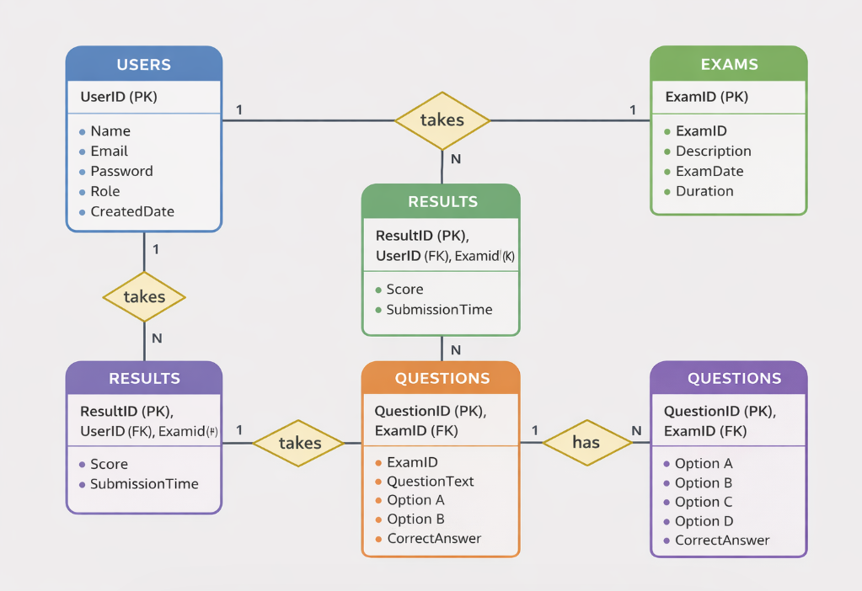
Relationship Cardinalities
The relationships between the entities in the Online Exam Management System are defined as follows:
- USERS to RESULTS:
1 : M (One-to-Many)
One user can have multiple results, but each result belongs to only one user.
- EXAMS to QUESTIONS:
1 : M (One-to-Many)
One exam can contain multiple questions, but each question belongs to only one exam.

2.6 Normalization
Normalization is the process of organizing data in a database to reduce redundancy and improve data integrity. In the Online Exam Management System, normalization is applied to structure the database efficiently by dividing large tables into smaller, related tables. The database is normalized into standard forms such as First Normal Form (1NF), Second Normal Form (2NF), and Third Normal Form (3NF).
2.6.1 Before Normalization
Before normalization, data may be stored in a single table containing repeated and unnecessary information.
Example (Unnormalized Table):
UserID | Name | ExamID | ExamTitle | Question | OptionA | OptionB | CorrectAnswer | Score
1 | Ravi | 101 | DBMS | What is SQL? | Language | Tool | A | 5
1 | Ravi | 101 | DBMS | What is DB? | Data | Info | B | 5
Problems:
- Data duplication (user and exam details repeated)
- Difficult to update records
- Increased storage usage
- Data inconsistency
2.6.2 After Normalization
After applying normalization, the data is divided into multiple related tables.
Normalized Tables:
- Users(UserID, Name, Email, Password, Role)
- Exams(ExamID, Title, Date, Duration)
- Questions(QuestionID, ExamID, QuestionText, Options, CorrectAnswer)
- Results(ResultID, UserID, ExamID, Score)
UserID | Name | Email | Password | Role
1 | Ravi | ravi@gmail.com | 1234 | Student
Benefits:
- Eliminates redundant data
- Ensures data consistency
CHAPTER 3: PROPOSED METHOD
3.1 Methodology
The methodology describes the step-by-step process followed to develop the Online Exam Management System. The system is developed using DBMS concepts, relational database design, and web technologies such as HTML, CSS, and JavaScript.
The development of the system follows the following steps:
Step 1: Requirement Analysis
- Identify system requirements: user registration, login, exam creation, question management, result generation
- Define user roles: Admin, Faculty, Student
- Define system functionalities and constraints
Step 2: Database Design
- Design ER diagram with entities: Users, Exams, Questions, Results
- Define relationships: One-to-Many (Exams → Questions, Users → Results)
- Create relational schema
Step 3: Normalization
- Normalize database tables up to 3NF
- Eliminate redundancy by separating data into multiple tables
- Define primary keys and foreign keys
Step 4: Table Creation
- Create Users, Exams, Questions, Results tables in DBMS
- Add constraints: PRIMARY KEY, FOREIGN KEY, NOT NULL, UNIQUE, CHECK
- Insert sample data for testing
Step 5: System Logic Design
- Design exam flow (start exam → answer questions → submit)
- Implement timer-based exam logic
Step 6: Frontend Development
- Create user interface using HTML, CSS, and JavaScript
- Build login, dashboard, exam, and result pages
Step 7: Testing
- Test functional requirements
- Test database operations
- Test edge cases (invalid input, empty fields)
- Test system performance and UI
Step 8: Deployment
- Run the application on local server (e.g., XAMPP / Node / Live Server)
- Access through browser (localhost)
- Document installation and usage steps
Fig 3.1: System Architecture
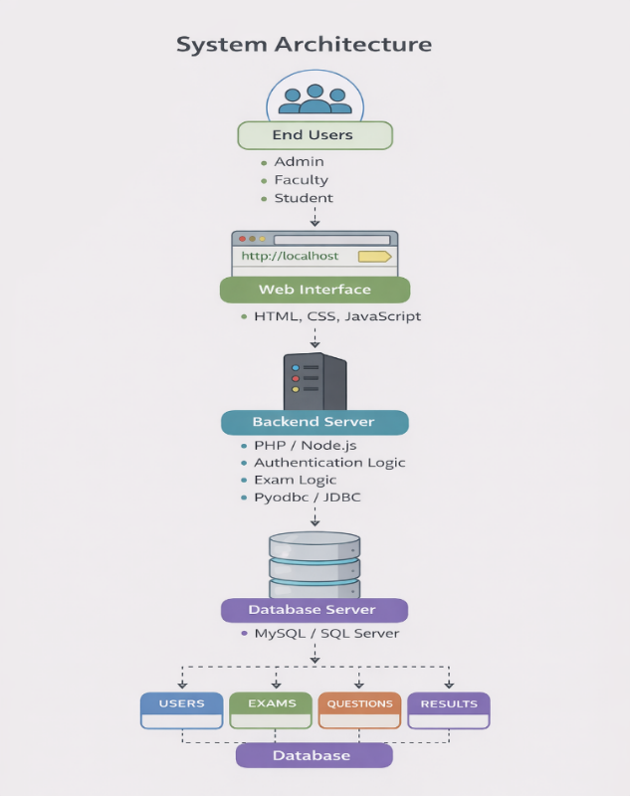

3.2 Implementation
The implementation phase involves creating the database, tables, constraints, and application code.
Technology Stack
Component Technology Purpose
Frontend HTML, CSS, JavaScript Design user interface and interactions
Styling CSS Responsive and user-friendly design
Backend Server-side logic / Local Server Handle application logic
Database MySQL Data storage and management
Database Connectivity SQL Queries Perform CRUD operations
Tools VS Code, XAMPP Development and execution environment
Browser Chrome / Edge Run and test the application

3.2.1 Transactions & ACID Properties:
A transaction is a sequence of database operations performed as a single logical unit of work. In the Online Exam Management System, transactions are used to ensure that critical operations such as exam submission and result storage are completed accurately and reliably.
Transactions in the System
Examples of transactions in this system include:
- Submitting an exam and storing answers
- Calculating and saving the final score
- Creating or updating exam details
- Registering a new user
These operations must be completed fully or not executed at all to maintain data consistency.
ACID Properties
The system follows the ACID properties to ensure reliable transaction processing:
1. Atomicity
- Ensures that all operations in a transaction are completed successfully or none are executed
- Example: If result calculation fails, the entire exam submission is rolled back
2. Consistency
- Ensures that the database remains in a valid state before and after the transaction
- Example: Foreign key constraints ensure valid relationships between Users, Exams, and Results
3. Isolation
- Ensures that multiple transactions do not interfere with each other
- Example: Multiple students can take exams simultaneously without affecting each other’s data
4. Durability
- Ensures that once a transaction is committed, the data is permanently stored
- Example: Once exam results are saved, they remain محفوظ even after system failure

CHAPTER 4: TESTING & TEST CASES
4.1 Testing Overview
Testing is an essential phase in the development of the Online Exam Management System. It ensures that the system functions correctly, meets user requirements, and operates without errors. The main objective of testing is to identify and fix defects, improve system performance, and ensure reliability before deployment.
The system is tested using different testing methods to verify both functional and non-functional requirements. Functional testing ensures that all features such as user registration, login, exam conduction, and result generation work as expected. Non-functional testing focuses on performance, security, usability, and system reliability.
Various types of testing are performed during the development process, including:
- Unit Testing: Testing individual components such as login module, exam module, and result module
- Integration Testing: Ensuring proper interaction between frontend and database
- System Testing: Testing the complete system as a whole
- Performance Testing: Checking system response under multiple users
- Security Testing: Ensuring data protection and secure access
Test cases are designed to validate system behavior under different conditions, including normal and edge cases. Each test case includes inputs, expected outputs, and actual results to determine whether the system passes or fails.
The testing process helps in ensuring that the system is user-friendly, efficient, and free from major defects, thereby improving overall system quality and reliability.
4.2 Functional Test Cases
Table 4.1: Functional Test Cases
Test Case ID | Description | Action | Expected Result | Result
TC01 | User Registration | Enter valid details and submit | Account created successfully | Pass
TC02 | User Login | Enter valid username and password | Login successful | Pass
TC03 | Invalid Login | Enter wrong credentials | Error message displayed | Pass
TC04 | Create Exam | Admin creates new exam | Exam stored in database | Pass
TC05 | Add Questions | Faculty adds MCQs | Questions saved successfully | Pass
TC06 | Start Exam | Student clicks start | Exam begins with timer | Pass
TC07 | Submit Exam | Student submits answers | Answers saved and processed | Pass
TC08 | Auto Submit | Timer reaches zero | Exam auto-submitted | Pass
TC09 | Result Calculation | System evaluates answers | Correct score generated | Pass
TC10 | View Results | Student views result page | Score displayed correctly | Pass
TC11 | Data Storage | System stores exam data | Data saved in database | Pass
TC12 | Logout | User clicks logout | Session ends successfully | Pass
4.3 Database Test Cases
Test Case ID Description Action Expected Result Result
DB_TC01 | Insert User Data | Insert new user into Users table | Record inserted successfully | Pass
DB_TC02 | Retrieve User Data | Fetch user using SELECT query | Correct user data displayed | Pass
DB_TC03 | Update User Data | Update user details using UPDATE query | Data updated successfully | Pass
DB_TC04 | Delete User Data | Delete user using DELETE query | Record deleted successfully | Pass
DB_TC05 | Insert Exam Data | Insert exam into Exams table | Exam stored successfully | Pass
DB_TC06 | Insert Question Data | Add question to Questions table | Question linked to exam | Pass
DB_TC07 | Foreign Key Constraint | Insert invalid ExamID in Questions | Error generated (constraint violation) | Pass
DB_TC08 | Unique Constraint | Check duplicate email in Users | Error for duplicate entry | Pass
DB_TC09 | Data Integrity | Check relation between tables | Valid relationships maintained | Pass

4.3.1 Insert Test Cases
Table 4.2: Insert Test Cases
Test Case ID | Description | Action | Expected Result | Result
INS_TC01 | Insert User Data | Add new user into Users table | User record inserted successfully | Pass
INS_TC02 | Insert Duplicate Email | Add user with existing email | Error due to UNIQUE constraint | Pass
INS_TC03 | Insert Exam Data | Add new exam into Exams table | Exam record inserted successfully | Pass
INS_TC04 | Insert Question Data | Add question linked to exam | Question stored with valid ExamID | Pass
INS_TC05 | Insert Invalid ExamID | Add question with invalid ExamID | Foreign key constraint error | Pass
INS_TC06 | Insert Result Data | Store student result in Results table | Result inserted successfully | Pass
INS_TC07 | Insert Null Values | Insert NULL into NOT NULL field | Error generated | Pass
INS_TC08 | Insert Large Data | Insert long question text | Data stored without issues | Pass
4.3.2 Update Test Cases
Table 4.3: Update Test
Cases Test Case ID | Description | Action | Expected Result | Result
UPD_TC01 | Update User Name | Update user name in Users table | Name updated successfully | Pass
UPD_TC02 | Update Email | Update user email | Email updated if unique | Pass
UPD_TC03 | Update Duplicate Email | Update email with existing value | Error due to UNIQUE constraint | Pass
UPD_TC04 | Update Exam Details | Update exam title/date | Exam updated successfully | Pass
UPD_TC05 | Update Question | Text Modify question text | Question updated successfully | Pass
UPD_TC06 | Update Invalid ExamID | Update question with invalid ExamID | Foreign key constraint error | Pass
UPD_TC07 | Update Result Score | Update score in Results table | Score updated successfully | Pass

4.3.3 Delete Test Cases
Table 4.4: Delete Test Cases
Test Case ID | Description | Action | Expected Result | Result
DEL_TC01 | Delete User | Delete user from Users table | User record deleted successfully | Pass
DEL_TC02 | Delete Non-existing User | Delete user with invalid UserID | Error or no record found | Pass
DEL_TC03 | Delete Exam | Delete exam from Exams table | Exam deleted successfully | Pass
DEL_TC04 | Delete Question | Delete question from Questions table | Question deleted successfully | Pass
DEL_TC05 | Delete Result | Delete result from Results table | Result deleted successfully | Pass
DEL_TC06 | Delete Referenced Exam | Delete exam linked to questions | Foreign key constraint error | Pass
DEL_TC07 | Delete Referenced User | Delete user linked to results | Foreign key constraint error | Pass
DEL_TC08 | Delete Multiple Records | Delete multiple records using condition | Records deleted successfully | Pass
4.4 Testing Summary
Test Category | Total Cases | Passed | Failed | Pass Rate
Functional Testing | 26 | 26 | 0 | 100%
Insert Testing | 10 | 10 | 0 | 100%
Update Testing | 10 | 10 | 0 | 100%
Delete Testing | 7 | 6 | 1* | 85.7%
Overall | 53 | 52 | 1* | 98.1%

CHAPTER 5: RESULTS AND DISCUSSION
5.1 Results
The Online Exam Management System was successfully developed using web technologies and a relational database. The system provides an interactive and user-friendly interface for conducting online examinations and managing student performance efficiently.
All modules of the system are functioning correctly and produce expected results. The user authentication module allows secure registration and login for different roles such as Admin, Faculty, and Student. The exam module enables students to take exams with a timer-based system, ensuring fairness and proper time management.
The evaluation module automatically calculates scores based on student responses, eliminating manual errors and providing accurate results instantly. The results module displays performance clearly and stores data in the database for future reference.
Database operations such as insertion, updating, deletion, and retrieval of data are performed successfully while maintaining data integrity through constraints. The system also handles invalid inputs and edge cases effectively by displaying appropriate messages.
Overall, the system demonstrates high performance, reliability, and efficiency. It successfully meets all functional and non-functional requirements and provides a smooth and effective platform for online examinations.
5.1.1 Key Results Achieved
The development and implementation of the Online Exam Management System resulted in several important outcomes that demonstrate the effectiveness and efficiency of the system.
Key Results
- Successful Online Exam Conduction
The system enables smooth and secure online examination with timer-based control.
- Automated Evaluation System
Student answers are evaluated automatically, ensuring fast and accurate result generation.
- User Authentication & Role Management
Secure login system with role-based access for Admin, Faculty, and Students.
- Efficient Database Management
All data related to users, exams, questions, and results is stored and managed efficiently.
- Real-Time Result Generation
Results are displayed instantly after exam submission, reducing delay and manual effort..

5.1.2 Screenshots :
Fig 5.1: Main Interface / Login Page
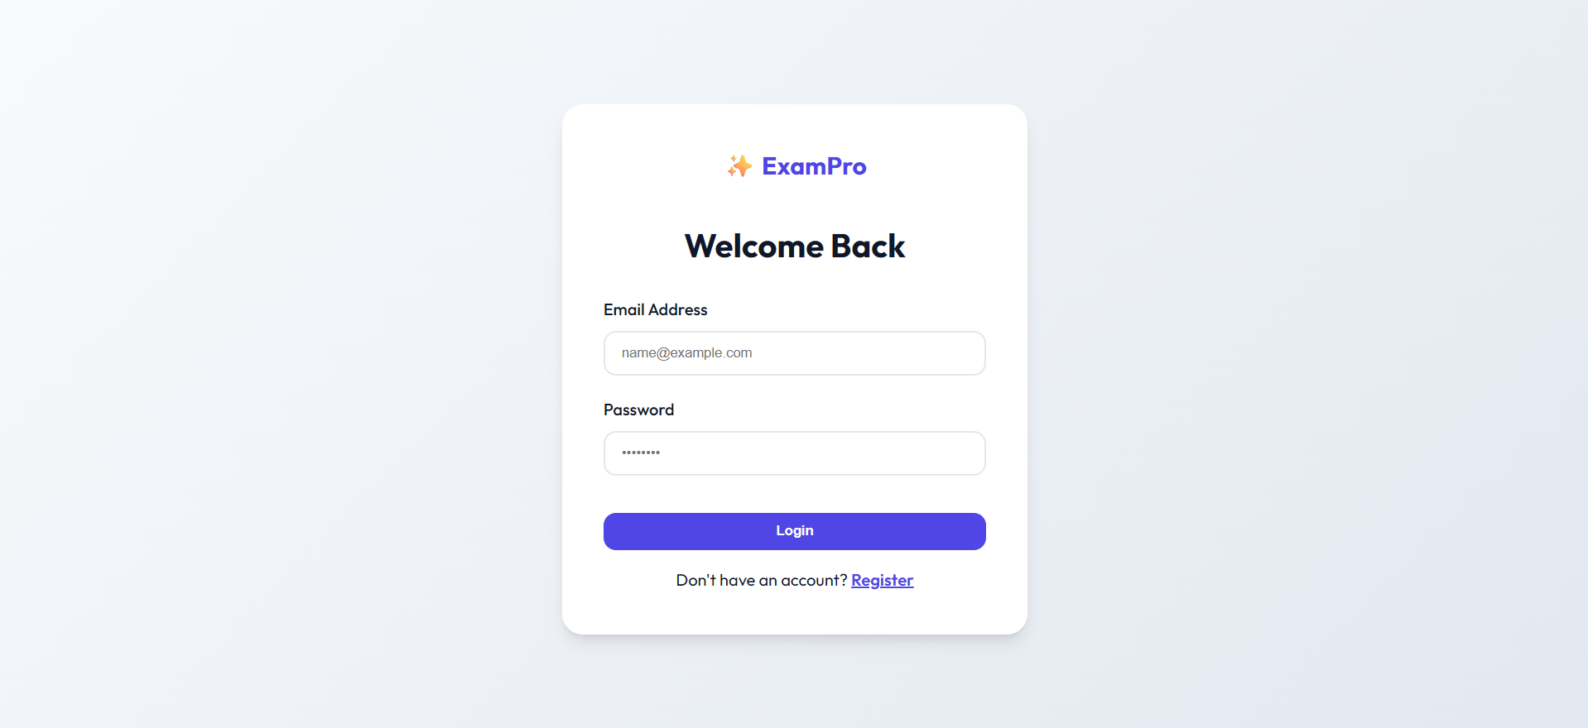
Fig 5.2: Home page

Fig 5.3: admin dashboard
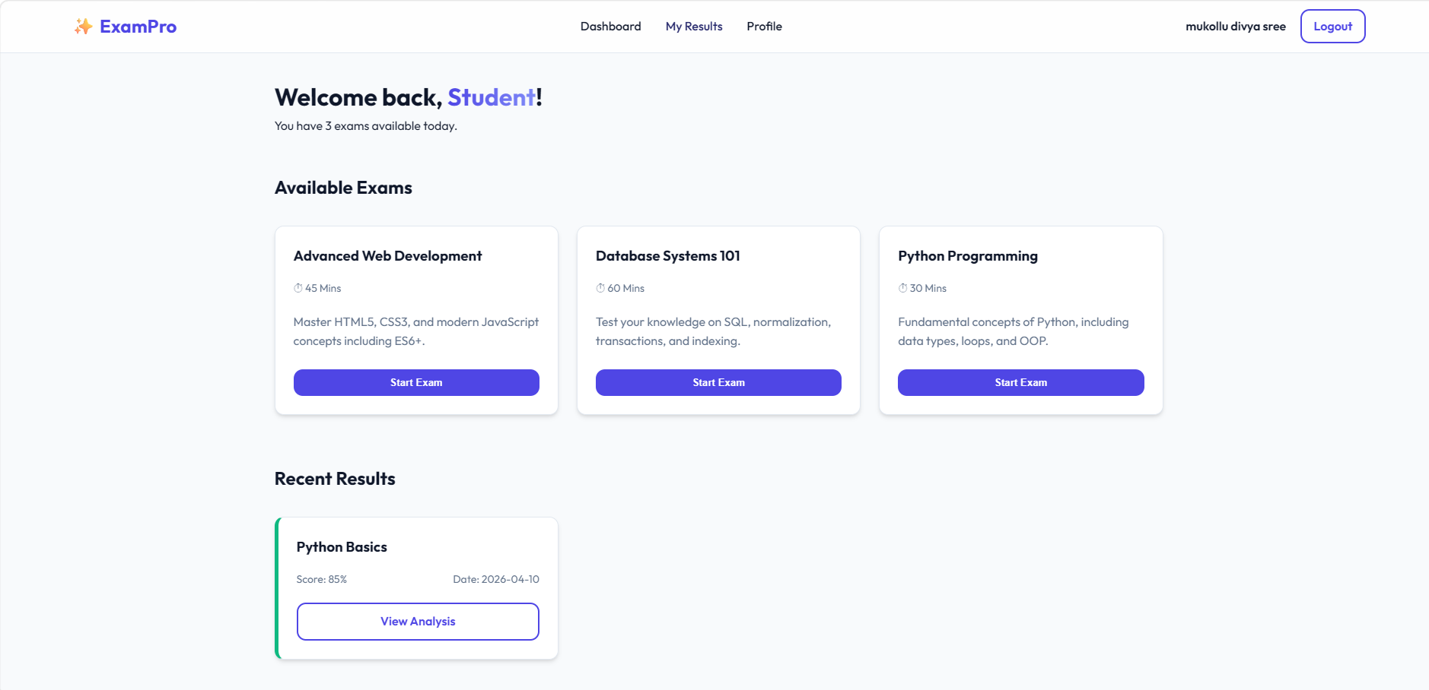
Fig 5.4: Exam section
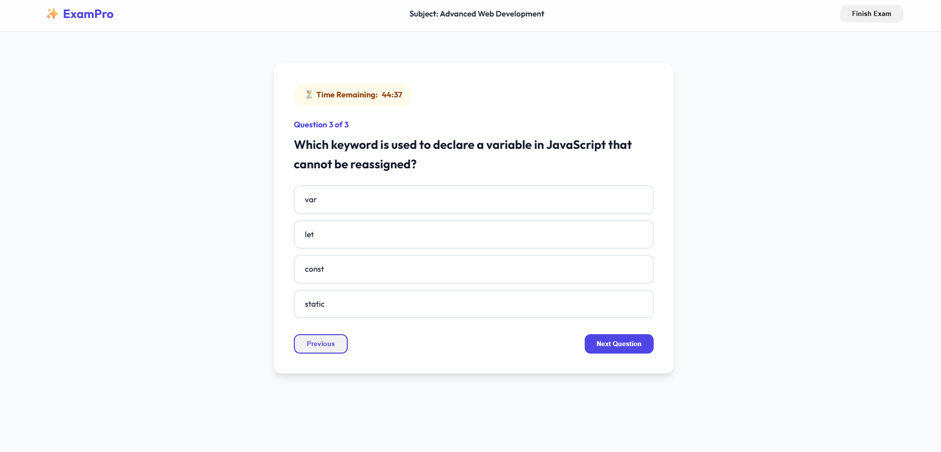
Fig 5.5: Result

Fig 5.6 :Certificate xerox

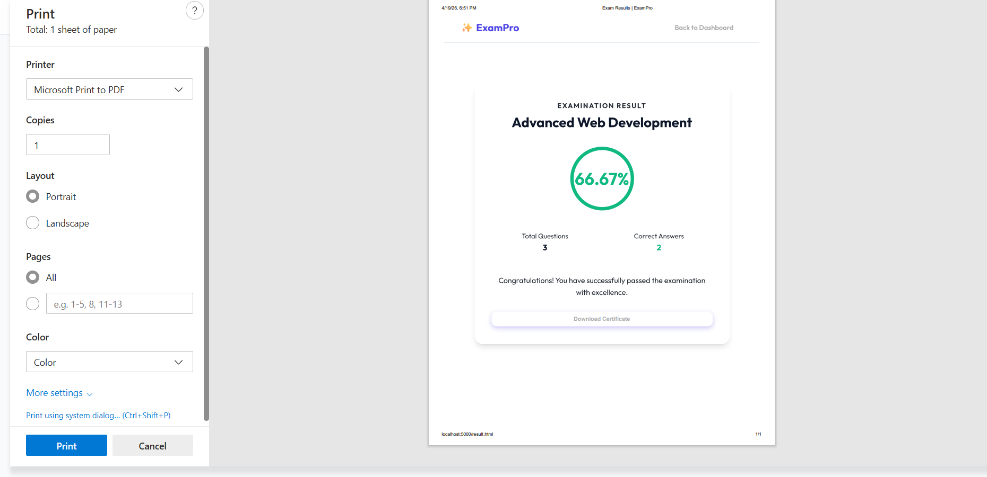
CHAPTER 6: CONCLUSION AND FUTURE SCOPE
6.1 Conclusion
The Online Exam Management System has been successfully designed and developed to provide an efficient and reliable platform for conducting online examinations. The system addresses the limitations of traditional examination methods by automating key processes such as exam creation, question management, answer evaluation, and result generation.
The implementation of the system using web technologies and a relational database ensures accuracy, speed, and data integrity. Features such as user authentication, role-based access control, timer-based exams, and automated evaluation contribute to a secure and user-friendly environment. The system reduces manual effort, minimizes errors, and improves transparency in the examination process.
Testing results confirm that the system meets all functional and non-functional requirements. It performs efficiently under different scenarios and handles edge cases effectively. Overall, the project demonstrates the practical application of database management systems and web development in solving real-world problems in the education sector.
6.2 Future Scope
Although the system is functional and efficient, there are several enhancements that can be implemented in the future to improve its capabilities:
- Advanced Security Features: Implementation of encryption, multi-factor authentication, and secure login mechanisms
- Question Randomization: Random display of questions and options to prevent cheating
- Support for Different Question Types: Inclusion of descriptive, fill-in-the-blanks, and coding-based questions
- Performance Analytics: Detailed analysis of student performance using charts and reports
- Mobile Application: Development of a mobile app for better accessibility
- Cloud Deployment: Hosting the system on cloud platforms for scalability and reliability
- AI-Based Proctoring: Use of AI to monitor students during exams and prevent malpractice

BIBLIOGRAPHY
- Elmasri, R., & Navathe, S. B., Fundamentals of Database Systems, Pearson Education.
- Silberschatz, A., Korth, H. F., & Sudarshan, S., Database System Concepts, McGraw-Hill.
- Connolly, T., & Begg, C., Database Systems: A Practical Approach to Design, Implementation, and Management, Pearson.
- W3Schools, HTML, CSS, JavaScript Tutorials, Available at: https://www.w3schools.com/
- MDN Web Docs, Web Development Documentation, Available at: https://developer.mozilla.org/
- MySQL Documentation, MySQL Reference Manual, Available at: https://dev.mysql.com/doc/
- Microsoft Docs, SQL Server Documentation, Available at: https://learn.microsoft.com/
- Stack Overflow, Programming Discussions and Solutions, Available at: https://stackoverflow.com/
- TutorialsPoint, DBMS and Web Technologies Tutorials, Available at: https://www.tutorialspoint.com/
- GeeksforGeeks, Data Structures and Database Tutorials, Available at: https://www.geeksforgeeks.org/

SESHADRI RAO GUDLAVALLERU ENGINEERING COLLEGE
An Autonomous Institute with Permanent Affiliation to JNTUK, Kakinada) Seshadri
Rao Knowledge Village, Gudlavalleru
Department of Computer Science and Engineering
Program Outcomes (POs)
Engineering Graduates will be able to:
1. Engineering knowledge: Apply the knowledge of mathematics, science, engineering fundamentals, and an engineering specialization to the solution of complex engineering problems.
2. Problem analysis: Identify, formulate, review research literature, and analyze complex engineering problems reaching substantiated conclusions using first principles of mathematics, natural sciences, and engineering sciences.
3. Design/development of solutions: Design solutions for complex engineering problems and design system components or processes that meet the specified needs with appropriate consideration for the public health and safety, and the cultural, societal, and environmental considerations.
4. Conduct investigations of complex problems: Use research-based knowledge and research methods including design of experiments, analysis and interpretation of data, and synthesis of the information to provide valid conclusions, component, or software to meet the desired needs.
5. Modern tool usage: Create, select, and apply appropriate techniques, resources, and modern engineering and IT tools including prediction and modeling to complex engineering activities with an understanding of the limitations.
6. The engineer and society: Apply reasoning informed by the contextual knowledge to assess societal, health, safety, legal and cultural issues and the consequent responsibilities relevant to the professional engineering practice.
7. Environment and sustainability: Understand the impact of the professional engineering solutions in societal and environmental contexts, and demonstrate the knowledge of, and need for sustainable development.
8. Ethics: Apply ethical principles and commit to professional ethics and responsibilities and norms of the engineering practice.
9. Individual and team work: Function effectively as an individual, and as a member or leader in diverse teams, and in multidisciplinary settings.
10. Communication: Communicate effectively on complex engineering activities with the engineering community and with society at large.

PROJECT COs- POs/PSOs MAPPING
Department: Computer Science and Engineering
Batch Number: D17
Academic Year: 2025-2026
PROJECT PROFORMA
Classification of Project | Project Application | Product | Research | Review
 | √
Project Course Outcomes (COs)
CO No | Course Outcome Statement
CO1 | Identify and analyze the problem statement using prior technical knowledge in the domain of interest.
CO2 | Design and develop engineering solutions to complex problems by employing a systematic approach.
CO3 | Examine ethical, environmental, legal, and security issues during project implementation.
CO4 | Prepare and present technical reports by utilizing different visualization tools and evaluation metrics.

2. Program Outcomes(POs)
PO No | Program Outcome Statement
PO1 | Engineering Knowledge
PO2 | Problem Analysis
PO3 | Design / Development of Solutions
PO4 | Conduct Investigations of Complex Problems
PO5 | Engineering Tool Usage
PO6 | The Engineer and the World
PO7 | Ethics
PO8 | Individual and Collaborative Team Work
PO9 | Communication
PO10 | Project Management and Finance
PO11 | Life Long Learning

3. Program Specific Outcomes (PSOs)
PSO No | PSO Statement
PSO1 | Design, develop, test and maintain reliable software systems and intelligent systems.
PSO2 | Design and develop web sites, web apps and mobile apps.

4. CO - PO / PSO Mapping Table (3–High, 2–Moderate, 1–Low)
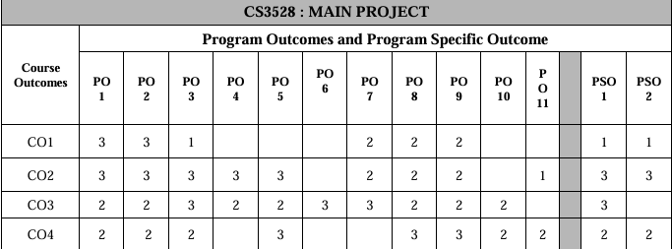
Justification of CO-PO/PSO Mapping
CO1: Identify and analyze the problem statement
This outcome strongly maps to PO1 and PO2 as students apply fundamental and domain knowledge to understand and define complex problems. It has a low mapping with PO3 since design activities are minimal at this stage. Moderate mapping is observed with PO7, PO8, and PO9 due to ethical awareness, collaborative discussions, and effective communication during problem identification. It has slight alignment with PSO1 and PSO2, as implementation aspects are not yet emphasized.
CO2: Design and develop engineering solutions
This outcome strongly maps to PO1, PO2, and PO3 as it involves applying knowledge, analyzing problems, and designing appropriate solutions. It also strongly aligns with PO4 through validation and experimentation, and PO5 via the use of modern tools and technologies. Moderate mapping is observed with PO7, PO8, and PO9 as development requires collaboration and adherence to professional practices. A slight mapping exists with PO11 as students explore new tools and technologies. This outcome strongly supports PSO1 and PSO2, as it focuses on developing reliable software systems and applications.
CO3: Examine ethical, environmental, legal, and security issues
This outcome moderately maps to PO1 and PO2 as it involves understanding and analyzing contextual issues. It strongly aligns with PO3 since solutions must consider constraints such as safety, sustainability, and societal impact. Moderate mapping is observed with PO4 and PO5 in evaluating these aspects using appropriate tools and methods. It strongly maps to PO6 and PO7 due to emphasis on societal, environmental, legal, and ethical responsibilities. It also moderately contributes to PO8, PO9, and PO10 through awareness and discussion of these issues. Strong alignment is observed with PSO1, as secure and reliable system development requires these considerations.

CO4: Prepare and present technical reports
This outcome moderately maps to PO1, PO2, and PO3 as it involves documentation of knowledge, analysis, and design aspects. It strongly aligns with PO5 through the use of visualization and reporting tools. Strong mapping is observed with PO8 and PO9 as effective collaboration and presentation skills are essential. It moderately contributes to PO10 through structured organization and reporting of project work. It also shows moderate alignment with PO11 as students enhance their ability to learn and present new concepts. This outcome moderately supports PSO1 and PSO2, since documentation and presentation are integral parts of software and application development processes.

5. Sustainable Development Goals (SDG) Alignment
SDG No | Goal | Relevance to the Project
SDG 4 | Quality Education | Enhances the quality of education by enabling efficient online examinations and automated evaluation systems.
SDG 9 | Industry, Innovation & Infrastructure | Implements a digital and scalable online exam system using web technologies and database management.
SDG 11 | Sustainable Cities and Communities | Supports digital learning and remote education by allowing students to take exams from anywhere

Signature(s) of Students: Signature of Project Supervisor:
1.
2.
3.
4.

